You can access <https://youtu.be/3ldQg3xBpLg> this link and see the demo video.

Zip is for all source code and war is for the war file.

INSTRUCTION

Access the main Page from the <http://18.221.50.218/applicationLayer/MainPage1.html>

CSC 7510 PROJECT REPORT 7

**Detailed Description of Components**

The following is a description of each functional component of the ImDB-like application as a servlet in the Tomcat container with a screenshot of how the developed front-end presents the response of the servlet if applicable. All of the servlets forward POST requests to the doGet method. If a request doesn’t specify a required parameter for the servlet, then the servlet will

return with a response that contains a reminder message and a link back to the main page. JDBC is used for all communication with the database and prepared statements are used when handling user submitted data.

**Main Page**

Main page will show some movie pictures in the gallery and on the op bar there will be three functions, one for user login, one for user sign up, and one for searching the view of the movie.

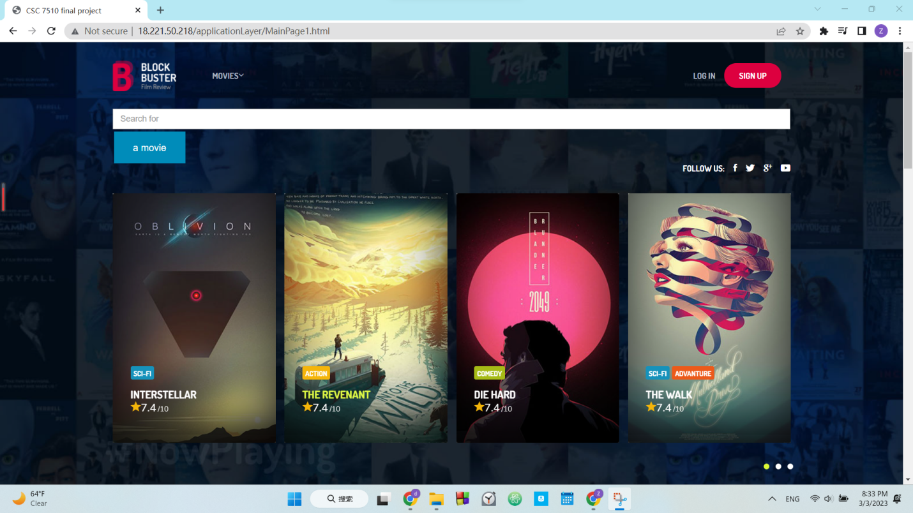

**Sign up**

The register servlet receives an name and password for registration

of a new account. If the information user input passed the system’ s policies checking, there will be redirected to a new page showing that it was successful. Then the servlet generates information needed to insert into the database. The database and servlet allow users to have the same name but with different U_id, and then insert a row into the database with the name,

CSC 7510 PROJECT REPORT 8

password, and U_id. The following screenshot is an example of an email sent by the servlet upon registration.



Picture 1, Sign up icon

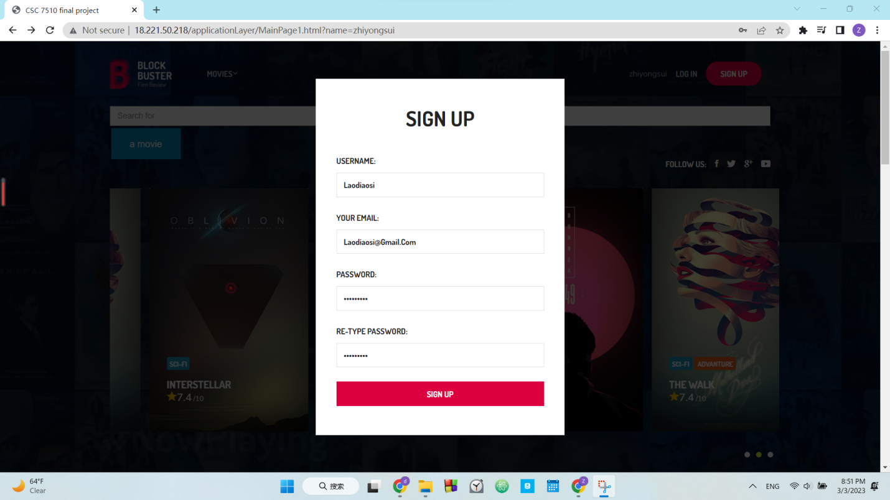

Picture 2, popup sign up window

CSC 7510 PROJECT REPORT 9

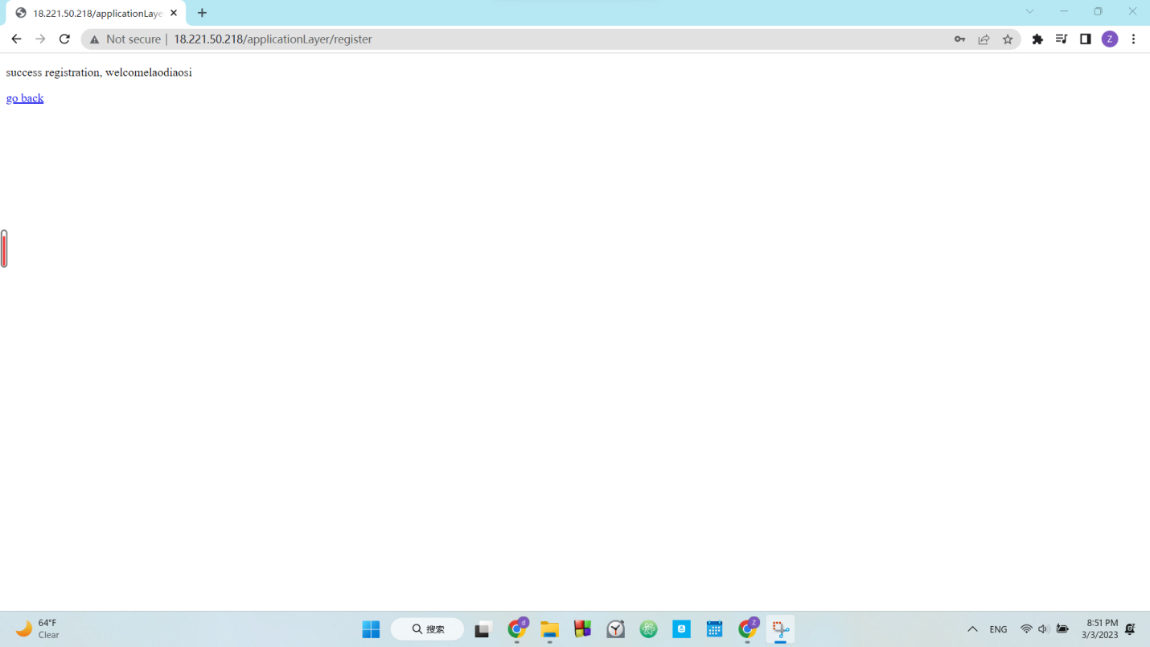

Picture 3, sign up success middle page.

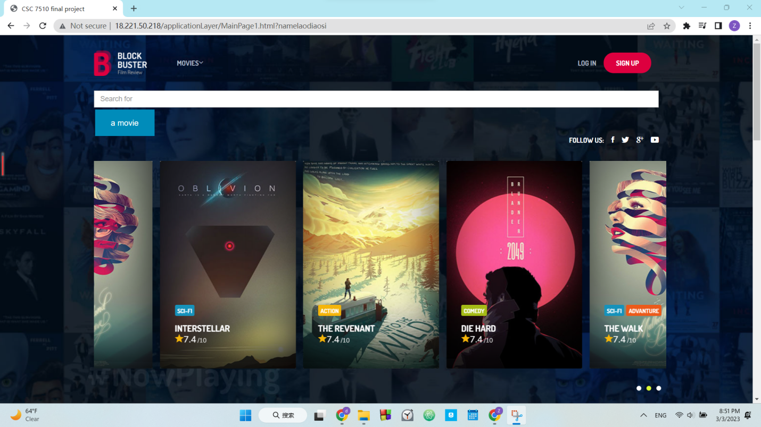

CSC 7510 PROJECT REPORT 10

Picture 4, return to main page after sign up

**Log in**

The login servlet receives a name and password for an account. If the information user input passed the system’ s policies checking, it will be redirected to a new page showing that it was successful. Then the servlet checks the name and password of the database to see if the user is legal to login. The database and servlet allow users to have the same name but with different U_id, and then insert a row into the database with the email, password, and U_id. The following screenshot is an example of an email sent by the servlet upon registration.



Picture 5, login icon

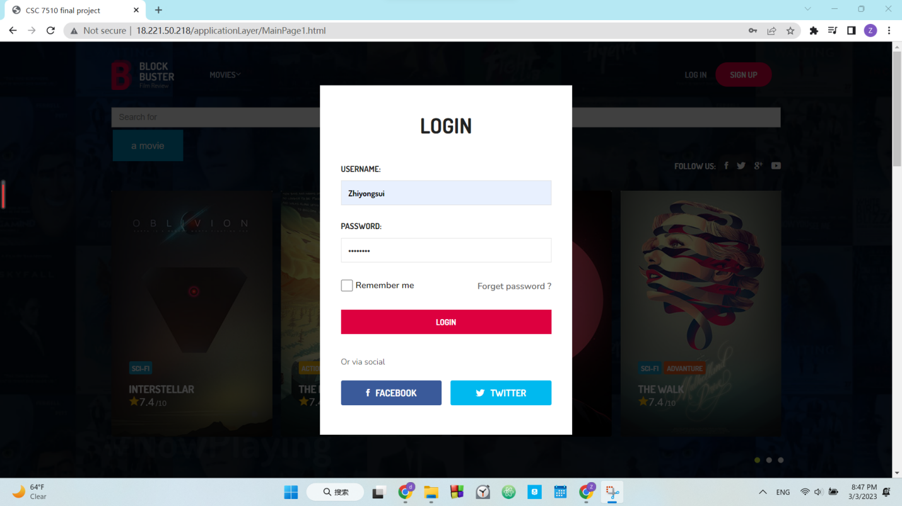

Picture 6, login pop up

CSC 7510 PROJECT REPORT 11

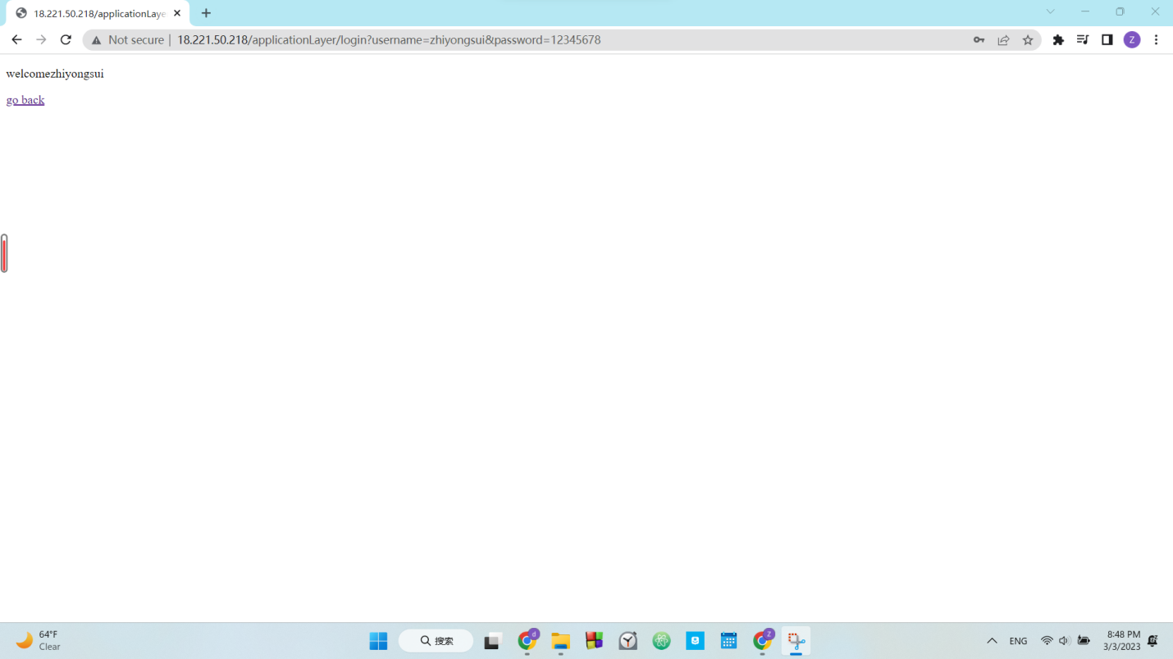

Picture 7, login middle page



Picture 8, name show in the top bar

**Search for actor**

The actor servlet receives a name for the movie and retrieves the actor's name from the database. If the movie name is really in the database and the actor’s name is not null. Application will redirect to page tell user success and have a go forward link to go to the result page. And there will be a new page showing the movie name, actors and picture.

CSC 7510 PROJECT REPORT 12

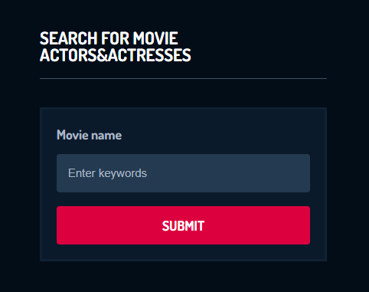

Picture 9, search for actor

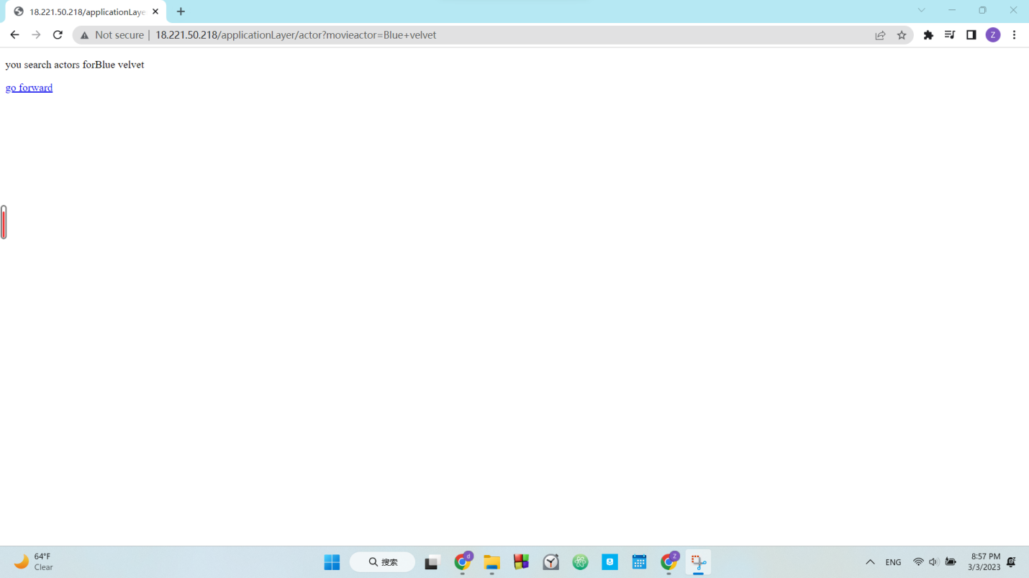

Picture 10, search for actor middle page

CSC 7510 PROJECT REPORT 13

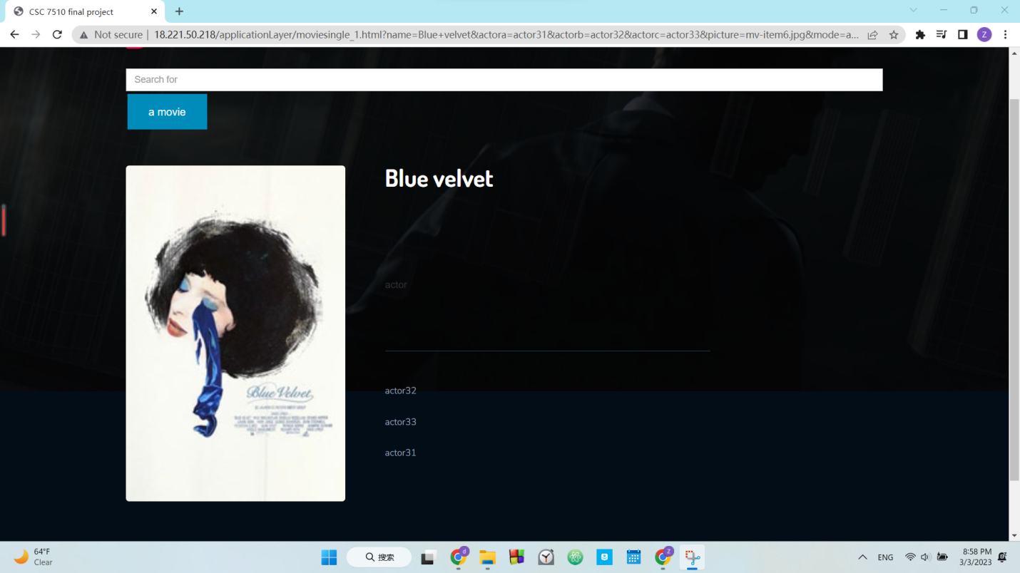

Picture 11, search for actor result page

**Search for movie’s producers**

The producer servlet receives a name for the movie and retrieves the producers’ name from the database. If the movie name is really in the database and the producers’ name is not null. Application will redirect to page tell user success and have a go forward link to go to the result page. And there will be a new page showing the movie name, producers and picture.

CSC 7510 PROJECT REPORT 14

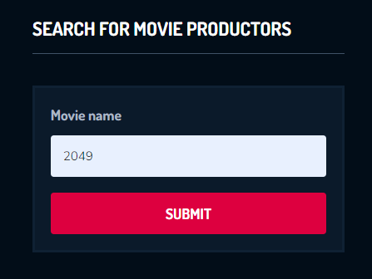

Picture 12, search for producer

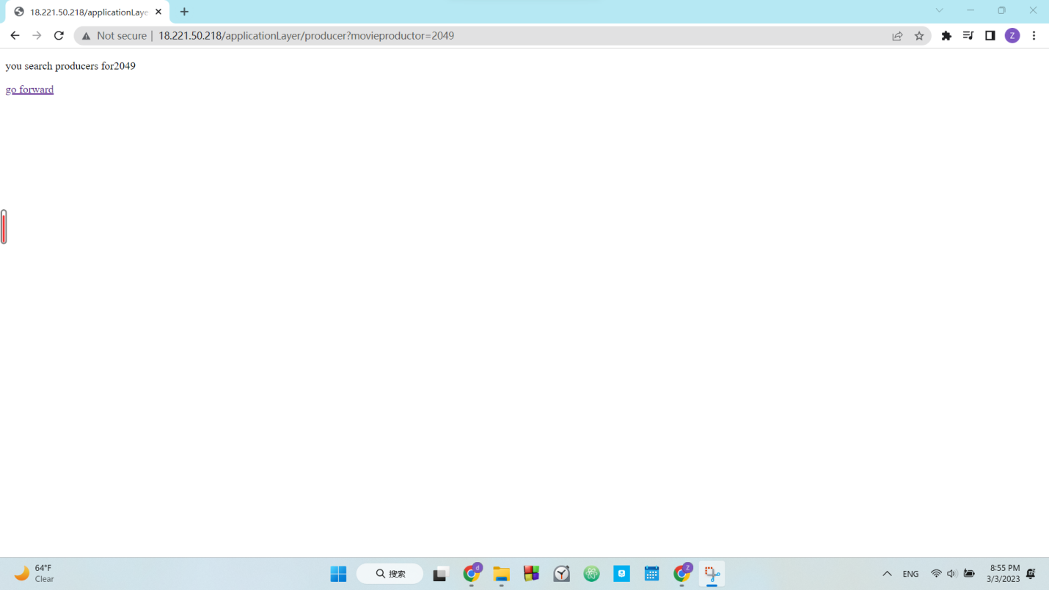

Picture 13, search for actor producer page

CSC 7510 PROJECT REPORT 15

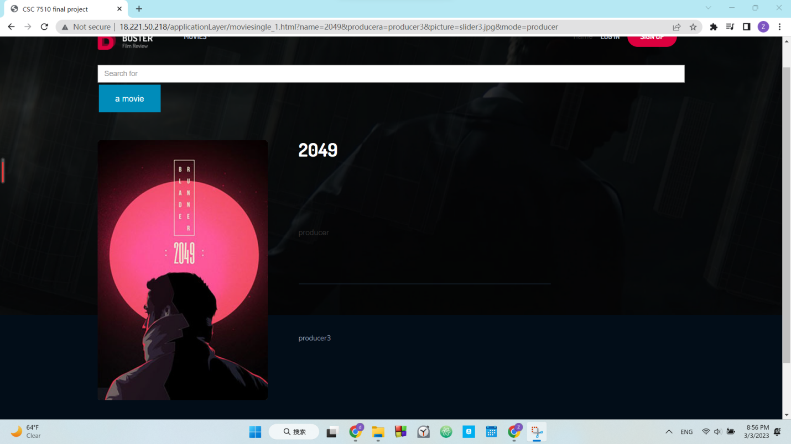

Picture 14, search for actor producer page

**Search for movie comments**

The comment servlet receives a name for the movie and retrieves the movie comments from the database. If the movie name is really in the database and the movie comments are not null. Application will redirect to page tell user success and have a go forward link to go to the result page. And there will be a new page showing the movie name, movie comments and picture.



Picture 15, search for movie comments

CSC 7510 PROJECT REPORT 16

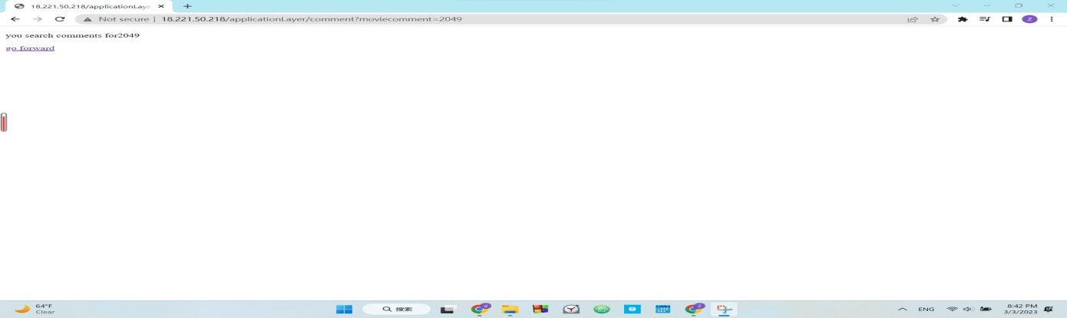

Picture 16, search for movie comments middle page

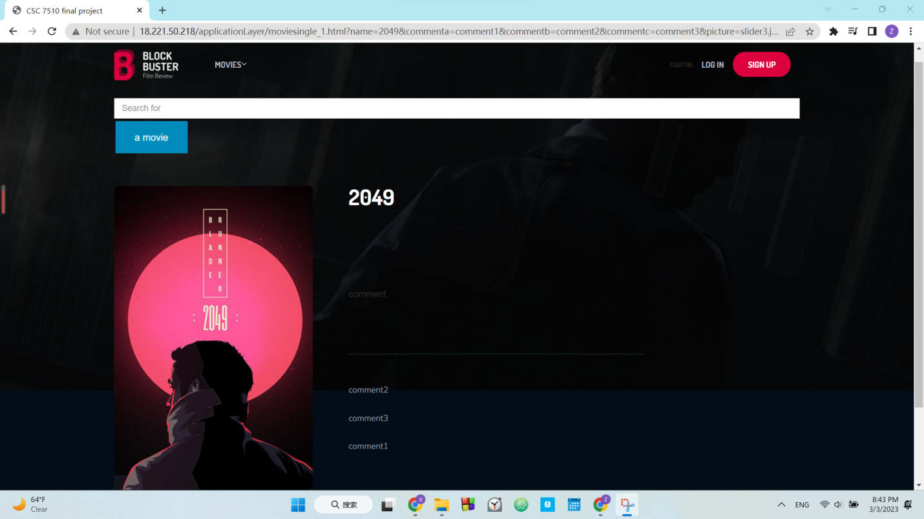

Picture 17, search for movie comments result page

CSC 7510 PROJECT REPORT 17

**Search for today movies**

The today servlet receives a name for the movie and retrieves the today's movies from the database. If the movie name is really in the database and the movies are not null. Application will redirect to page tell user success and have a go forward link to go to the result page. And there will be a new page showing the movie name, picture.



Picture 18, search for today movies

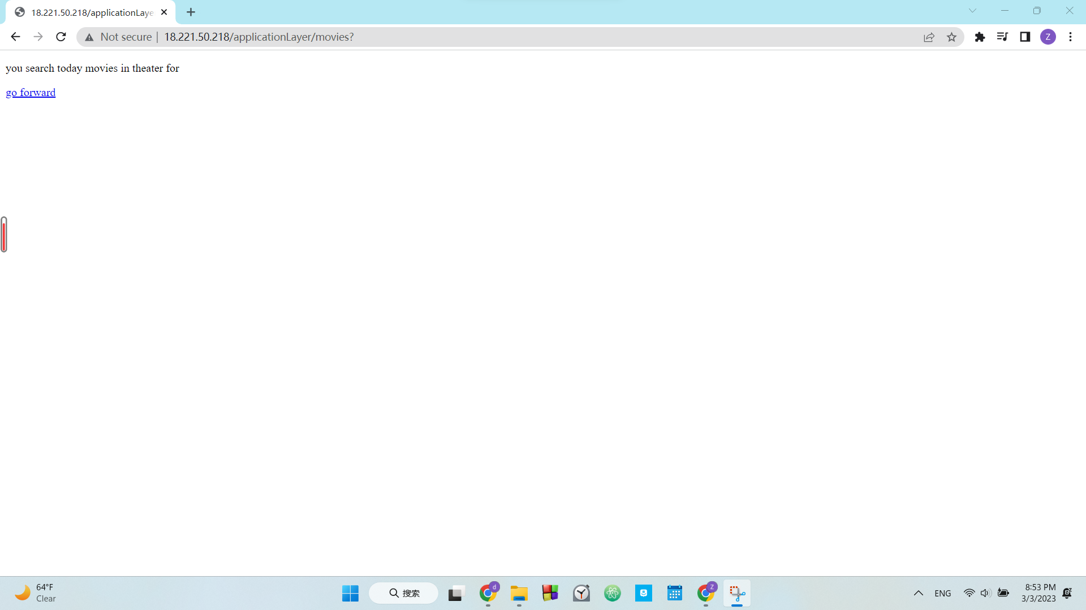

CSC 7510 PROJECT REPORT 18

Picture 19, search for today movies middle page

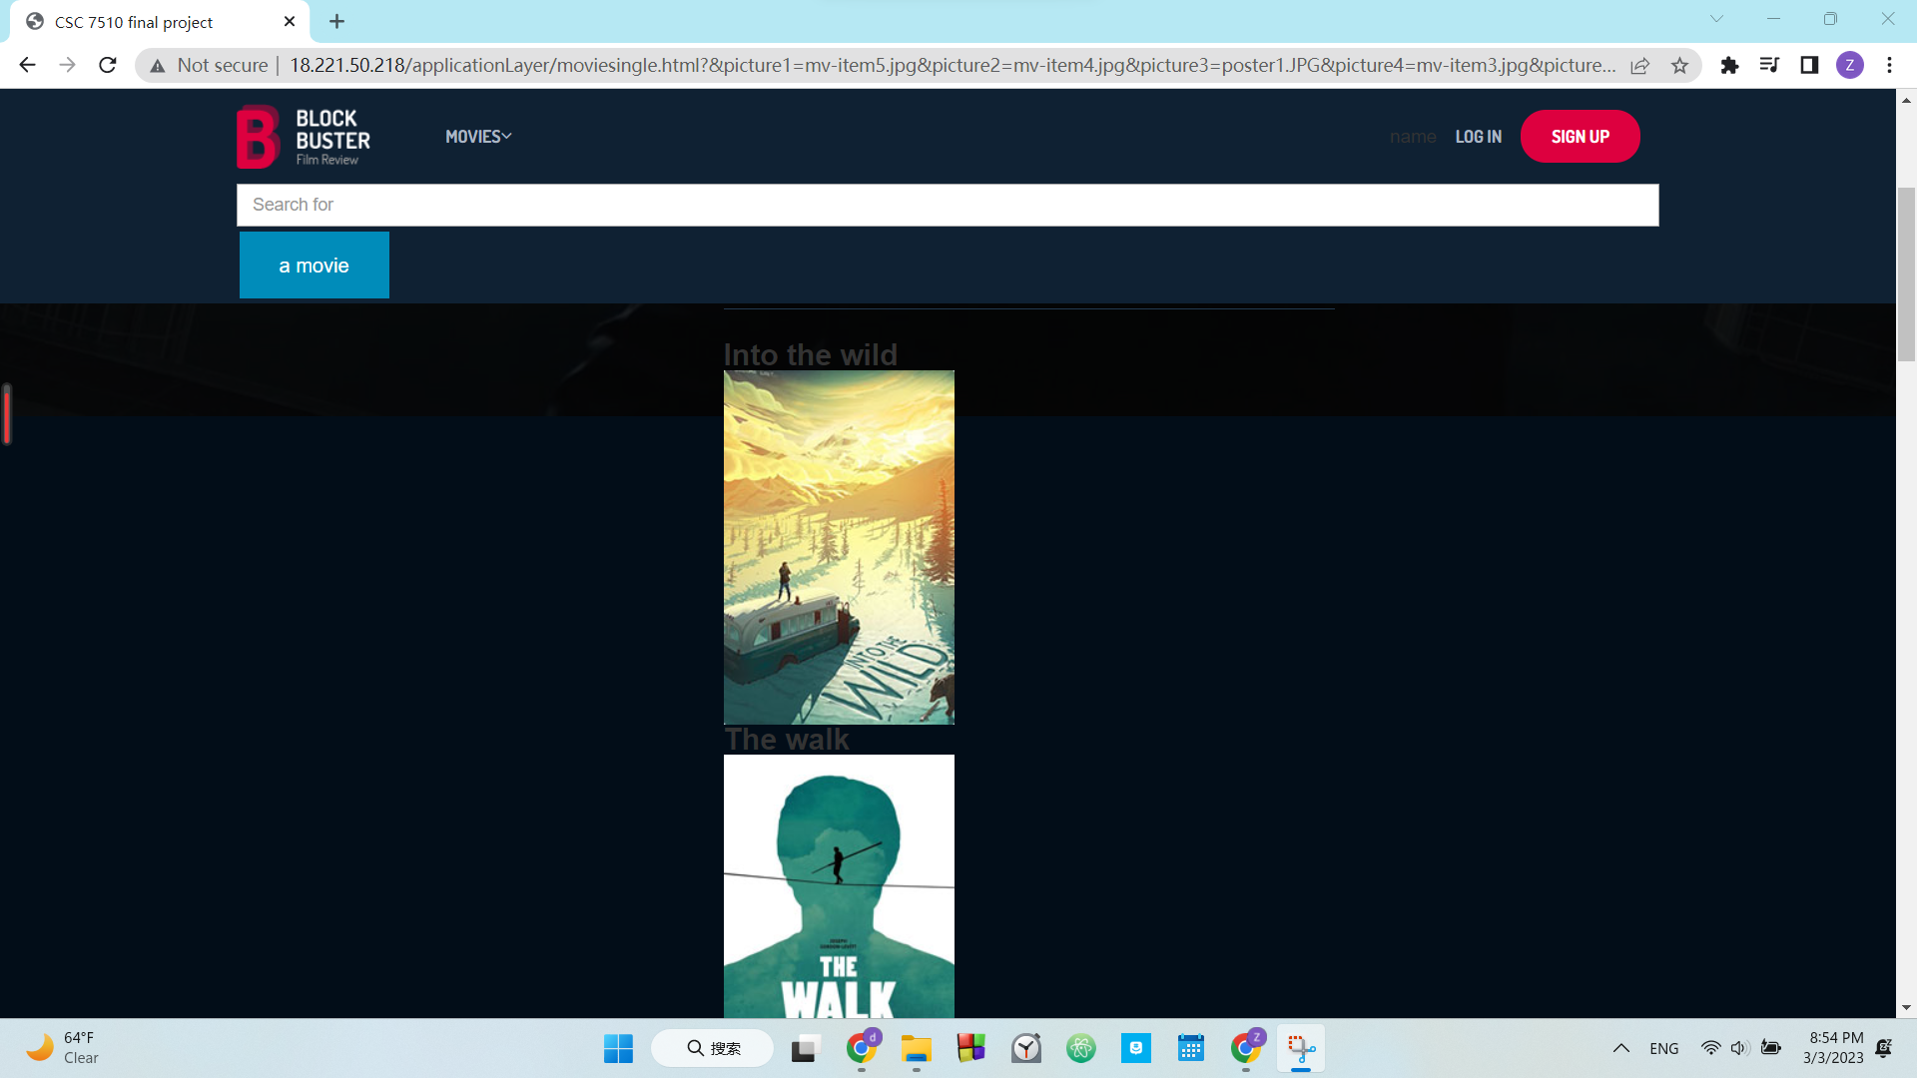

Picture 20, search for today movies result page

**Search for top 10 hottest movies**

The movies servlet receives a name for the movie and retrieves the top 10 hottest movies from the database. If the movie name is really in the database and the movies are not null. Application will redirect to page tell user success and have a go forward link to go to the result page. And there will be a new page showing the movie name, picture.

CSC 7510 PROJECT REPORT 19



Picture 21, search for top 10 hottest movies



Picture 22, search for top 10 hottest movies middle page

CSC 7510 PROJECT REPORT 20



Picture 23, search for top 10 hottest movies result page

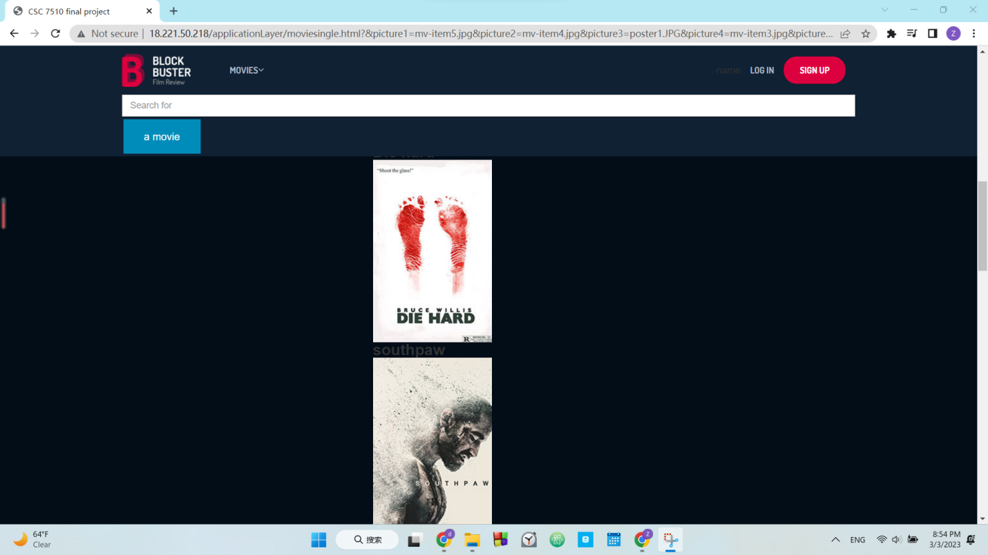

Picture 24, search for top 10 hottest movies result page

CSC 7510 PROJECT REPORT 21

**Search for movies view**

The view servlet receives a name for the movie and retrieves the view from the database. If the movie name is really in the database and the movie's views are not null. Application will redirect to page tell user success and have a go forward link to go to the result page. And there will be a new page showing the movie name and view.

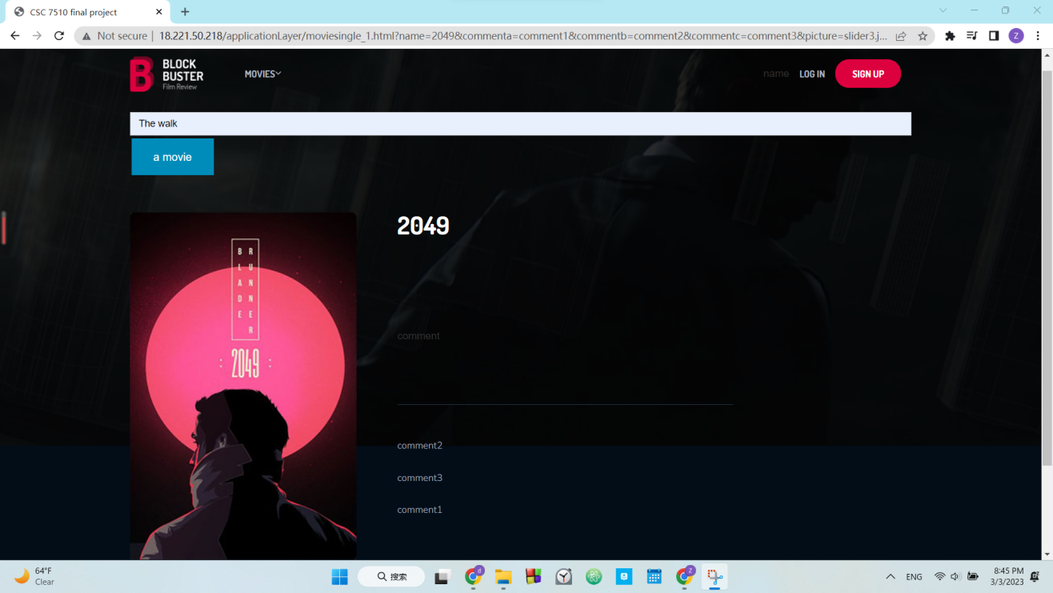

Picture 25, search for movie view

CSC 7510 PROJECT REPORT 22

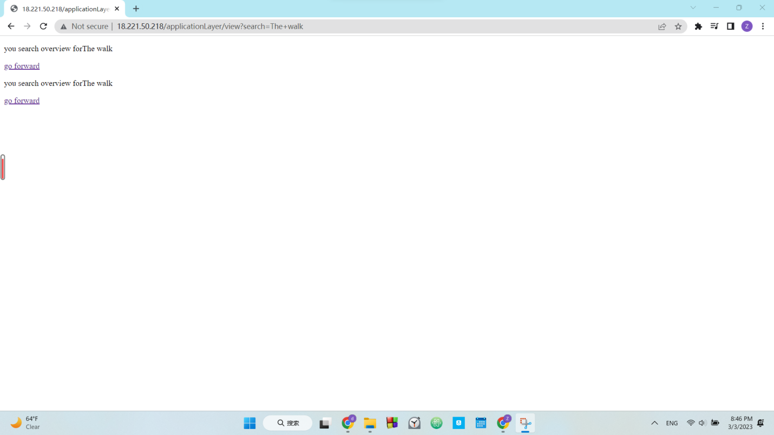

Picture 26, search for movie view middle page

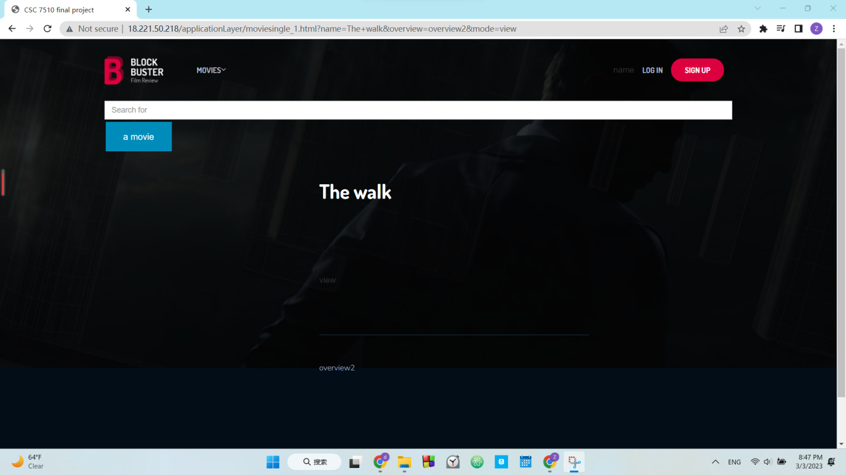

Picture 27, search for movie view result page